**TRINITY LUTHERAN SCHOOL**

**FIRST SEMESTER, 2023 ACADEMIC YEAR PROJECT WORK BS7.**

**HUMAN ACTIVITIES THAT AFFECT MAJOR PHYSICAL FEATURES SUCH AS MOUNTAIN, WATER BODIES AND OCEANS.**

**SUBMITTED BY:**

**BRIANNA NIBENAALONG YOB**

**DATED : 19-06-2023**

**ACKNOWLEDGEMENT**

My first acknowledgement goes to the Almighty God for helping me to write this project work successfully.

I also appreciate the help from my parents for helping me and also pushing me to finish.

**TABLE OF CONTENT**

CHAPTER 1 : INTRODUCTION

CHAPTER 2: DESCRIPTION OF THE MAJOR PHYSICAL FEATURES.

CHAPTER 3: THE HUMAN ACTIVITIES THAT AFFECT THE MAJOR PHYSICAL FEATURES.

CHAPTER 4: POSSIBLE PROTECTIVE MEASURES

CHAPTER 5: CONCLUSION

INCLUDING THE FOLLOWING

* GLOSSARY
* REFERENCE

**CHAPTER 1: INTRODUCTION**

The major physical features that human activities affected are :

* Major Mountain Ranges
* Water Bodies
* Oceans

**MAJOR MOUNTAIN RANGES**

A mountain range or a hill range is a series of mountains or hills arranged in a line and connected by a high ground.

A mountain system or a mountain belt is a group of mountain ranges with similarity in form, structure and alignment that have risen from the same cause, usually an orogeny. Mountain ranges are formed by a variety of geological processes but are the result of plate tectonics.

Mountain ranges are also found on many planetary mass objects in the solar system and are likely a feature of most terrestrial planets.

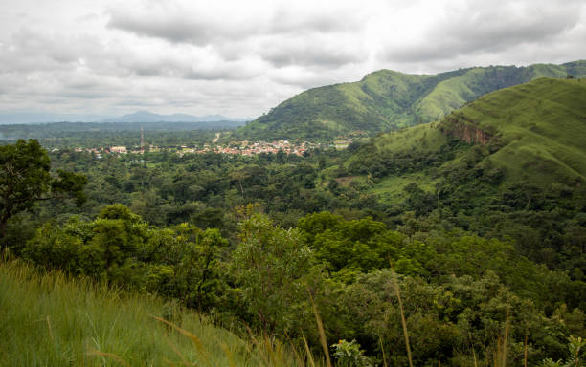

***FIGURE 1.0***

MOUNTAIN RANGE IN VOLTA REGION

Mountain ranges are usually segmented by highlands or mountain passes and valleys. Individual mountains within the same mountain range do not necessarily have the same geologic structure or petrology. They may be a mix of different orogenic expressions and terranes for example thrust sheets, uplifted blocks, fold mountains and volcanic landforms resulting in a variety of rock types.

**WATER BODIES**

Water Bodies is any significant accumulation of water on the surface of Earth or another planet. The term most often refers to oceans, seas, lakes, but it includes smaller pools of water such as ponds, wetlands or more rarely. The five oceans are namely; the pacific ocean, atlantic ocean, indian ocean and the southern ocean.

Today we have five bodies of water and one world ocean or 5 oceans A.K.A Ocean 5, and two seas covering over 71 percent of the earth's surface and 97 percent of the Earth's water.

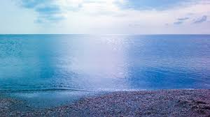

***FIGURE 1.1***

WATER BODIES

**OCEANS**

The ocean (also known as the sea or world ocean) is a body of salt water that covers approximately 70.8% of earth’s water. The term ocean also refers to any of the large bodies of water into which the world ocean is conventionally divided. Five distinct names are used to identify five different areas of the ocean: Pacific (largest), Atlantic, Indian, Southern, and Arctic(smallest).

Sea water covers approximately 361,000,000.km(139,000,0005q mi) of the planet. The ocean is the primary component of the Earth Hydrosphere and thus essential to life on earth. The ocean influences climate and weather puttering, the carbon cycle and water cycle by acting as a huge heat reservoir.

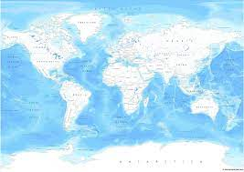

***FIGURE 1.2***

OCEAN DIVISIONS

Centre = 92°24’42’5’

177°22’45”E (See also water Hemisphere in the south Pacific Ocean.

Pole of inaccessibility = 123°23.6’W approximately 2,888km (1,670 mi) from the nearest land.

**CHAPTER 2: DESCRIPTION OF MAJOR RELIEF FEATURES**

Major relief features of the earth are the continents and ocean basins were created by the movement of plates on the surface of the earth. Geologists use the term lithosphere to describe an outer Earth shell of rigid, brittle rock, including the crust and also the cooler, upper part of the mantle.

The main relief features are hills, valleys, plateous, plains, river bains, rocky and sandy places.

**MOUNTAINS**

A mountain is an elevated position of the earth’s crust generally with steep sides that show significant exposed bedrock. Mountains form where two continental plates collide. Since both plates have similar thickness and weight neither one will sink under the other. Instead, they crumple and fold and fold until the rocks are forced up to form a mountain range. As the plates continue to collide, mountains will get taller and taller. The highest mountain in the is mount Everest located at Nepal/China, Asia its height is 29,029ft.

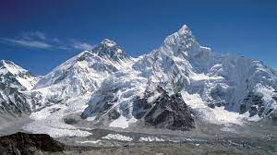

***FIGURE 1.3***

Mount Everest

**HILL**

A hill is a landform that is higher than the surrounding area. On the other hand, a hill is a land that rises above its surrounding and has a rounded summit, usually less than 300 metres (1,000 feet).

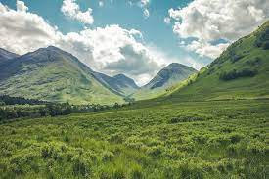

***FIGURE 1.4***

Hill

**SANDY OR ROCKY PLACE**

The area where the ocean meets a shore can contain many rocks or small pebbles which in some instances are generated by erosion.

Intertidal zones exist everywhere the ocean meets the land, from steep rocky ledges to the long sloping sandy beaches and mudflats that can extend for hundreds of metres.

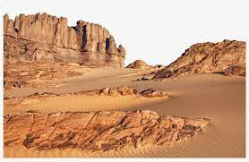

***FIGURE 1.5***

Sandy or Rocky Place

**BASINS**

A river drainage basin is an area drained by a river and all of its tributaries. A river basin is made up of many different watersheds.

A watershed is a small version of a river basin. Every stream and tributary has its own watershed which drains to a larger stream or wetland.

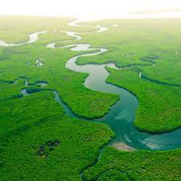

***FIGURE 1.6***

Basin

**PLAIN**

In geography, a plain is commonly known as flatland , is an expanse of land that generally does not change much in elevation and is primarily treeless. Plains occur at low lands along valleys, or at the base of mountains, as coastal plains.

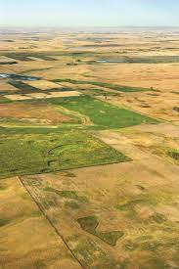

***FIGURE 1.7***

Plain

**CHAPTER 3: THE HUMAN ACTIVITIES THAT AFFECT MAJOR PHYSICAL FEATURES**

These activities include, land use change, wind management, land degradation, soil sealing and mining.

However, the intensity of land used also has a great impact on soils which is why there is a rise in problems like soil erosion and depletion of soils.

Humans impact the physical environment in many ways: Overpopulation, Illegal Mining, Pollution, Soil Sealing, Burning Fossil fuels, Soil Erosion, Poor air quality and Undrinkable water.

**OVERPOPULATION**

This is the state whereby the human population rises to an extent exceeding the carrying capacity of the ecological setting.

**POLLUTION**

This is the introduction of harmful materials into the environment.

**SOIL EROSION**

This is a gradual process that occurs when the impact of water or wind detaches and removes soil particles causing the deterriorate.

**ILLEGAL MINING**

This is a mining activity that is undertaken without state permission.

**SOIL SEALING**

Changing the nature of the soil such that it behaves as an impermeable medium.

**CHAPTER 4: POSSIBLE PROTECTIVE MEASURES**

1. We must practise afforestation and reafforestation programmes to replace the forest that has been destroyed.
2. Law against bush fires should be enforced so as to punish offenders.
3. Human waste should be used to generate biogas instead of disposing into seas.
4. People should plant trees in various communities.
5. Factories which are cited in the city's centres should be relocated to the outskirts of the cities.
6. Education and Awareness: Informing local communities about the risk and potential hazards associated with physical features can empower individuals to take appropriate measures. Educating people on safety protocols, emergency preparedness, and raising awareness about environmental preservation can significantly reduce vulnerablity.

**CHAPTER 5: CONCLUSION**

The major relief features are in danger because of these human activities which can cause harm to the world. Some of these human activities includes:

* Deforrestation
* Desertification
* Using chemicals for fishing
* Throwing of human waste into the sea

But there are some things we can do to protect the environment.

Some include:

* Practising reafforestation
* Educating the people against these practices
* Good Fishing practices
* Agencies like the National Fire Service can be well equipped to control fire outbreaks.

**GLOSSARY**

Alignments - Arrangement in a straight line or in correct relative positions.

Accumulation- The acquision or gradual gathering of something.

Approximately- Use to show that something is almost, but not completely, accurate or exact roughly.

Plate Tectonics- Is a scientific theory that explains how major landforms are created as a result of earth subsequent movements.

Plantory Mass- Is a measure of the mass of a planet like astronomical objects.

Petrology- The branch of science concerned with the origin, structure and composition of rocks.

Terranes- A stretch of land, especially with regard to its physical features.

Thrust Sheets- Is a large sheet like body of rock that has been from more than two km

( 1.2 mi) or five km ( 3.1 mi) above a thrust fault from its original position.

Landforms- Is a feature on earth's surface that is part of the terrain mountain, hills, plateaus and plains.

**REFERENCE**

* Social Studies Notebook
* Google -

Wikipedia

Study Iq

Byjus

National geographic

Milwaukee Riverkeeper